AI Assisted Coding
ASSIGNMENT-1S

Name: B. Rithwik
HT No: 2303A52330
Batch: 35

Lab 1G – Code Translation: Converting Between Programming Languages Objective
- To understand how AI assists in translating code between programming languages.
- To compare syntax and structure across languages like Python, Java, C++, and SQL.
- To verify correctness and functionality of translated code.
- To debug and optimize AI-generated code.

Task 1 – Python to Java Conversion Aim
To translate a Python class into an equivalent Java class.
Python Code
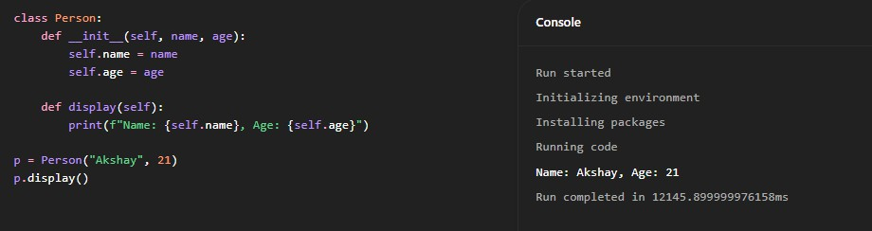
Java Code

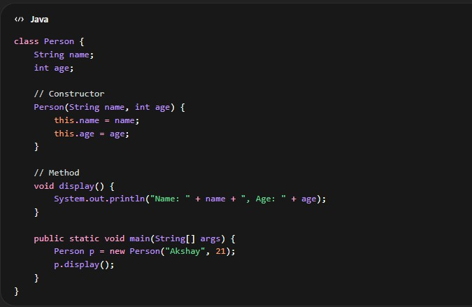
Result
The Java class successfully replicates the functionality of the Python class with proper constructor and method implementation.

Task 2 – C++ to Python Function Conversion Aim
To convert a recursive factorial function from C++ to Python.
C++ Code
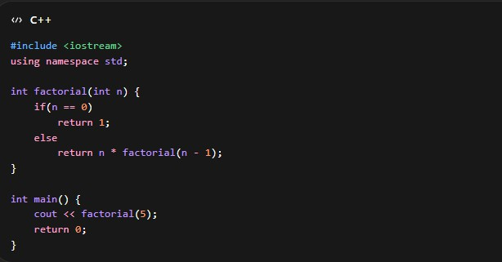
Python Code

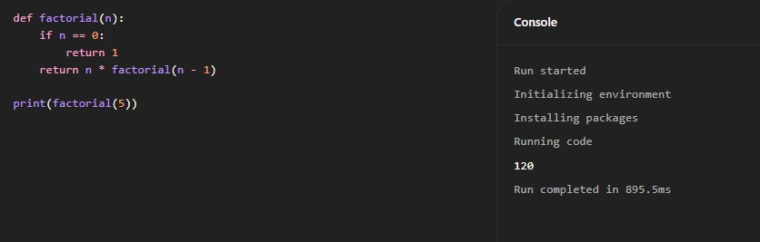
Result
The Python function correctly computes factorial values and follows Pythonic syntax.

Task 3 – SQL to Pandas Query Aim
To convert a SQL query into an equivalent Pandas operation.
SQL Query
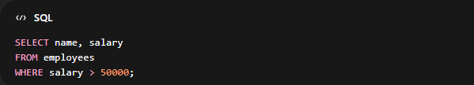
Pandas Code
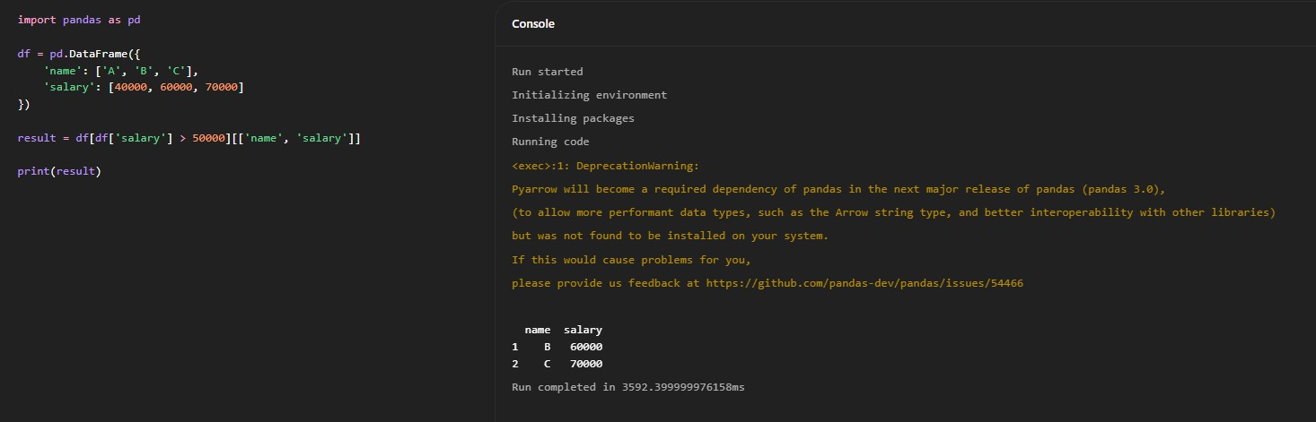

Result

The Pandas query successfully filters and retrieves the required subset of data equivalent to the SQL query.

Task 4 – Real-Time Application: Multi-Language Snippet Converter Aim

To translate code between two programming languages for a real-world scenario.

Use Case

Convert a Python web scraping script into JavaScript for browser automation. Python Code (Web Scraping)
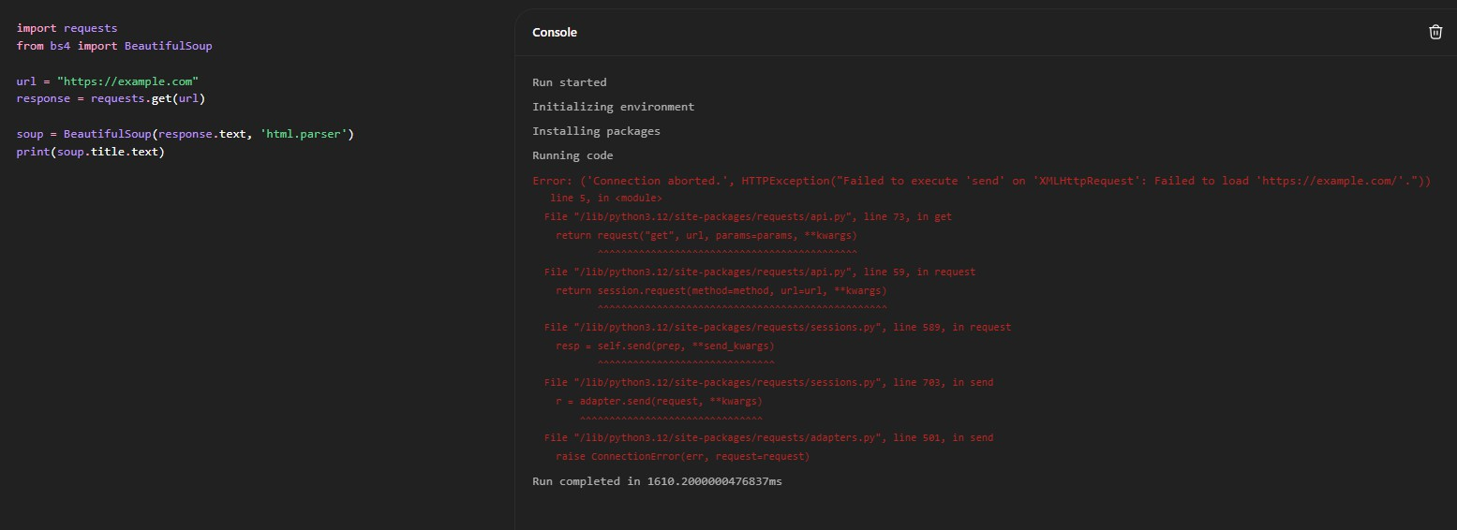
JavaScript Code (Browser Automation)
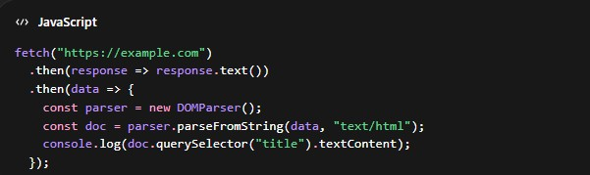
Challenges Faced
- Differences in syntax and structure between languages.
- Library variations (BeautifulSoup vs DOMParser).
- Handling asynchronous behavior in JavaScript.

Result
Equivalent functionality was achieved in both languages, demonstrating successful translation.
Conclusion
AI-assisted code translation simplifies converting programs between languages. However, understanding syntax, libraries, and execution models is essential to ensure correctness and efficiency. Manual verification and debugging remain crucial steps.

